EXPERIMENT 8: CREATE STORYBOARDS TO REPRESENT THE USER FLOW FOR A MOBILE APP USING BALSAMIQ
Name:Jovitha J Roll number: 240701219

Aim:
The aim of this experiment is to design and represent the user flow of a mobile food ordering application by creating low-fidelity storyboards using Balsamiq. The purpose is to visualize the sequence of user interactions — from searching food items to order confirmation — and to evaluate how storyboarding supports clarity, usability, and iterative design in mobile app development.

About the App
The app, foodie.o, is a simple food ordering application that allows users to:
- Search for their favourite food items.
- Browse a menu with prices and add items to their order.
- View and edit their order summary.
- Choose from multiple payment options.
- Receive order confirmation with delivery details.

Procedure
- Define Purpose and Features
  - Identify core features: search food, menu listing, order summary, payment, confirmation.
  - Map out the user journey step by step.

Create Storyboards in Balsamiq
- Use Balsamiq’s wireframe components (buttons, text fields, icons) to sketch each screen.
- Design panels for:
  - Search screen (food categories).
  - Menu page (items with prices and add buttons).
  - Order summary page (selected items, total, proceed to pay).
  - Payment options page.
  - Order confirmation page.

Connect Screens with Flow Arrows
  - Show transitions between screens (e.g., Search → Menu → Order → Payment → Confirmation).
  - Ensure logical navigation and smooth progression.

Review and Refine
  - Share the storyboard with peers or stakeholders.
  - Collect feedback on clarity and usability.
  - Adjust layouts, labels, or flow connections based on feedback.

Finalize Storyboard
  - Present the complete storyboard as a visual representation of the app’s user flow.
  - Document how the storyboard supports iterative design and user-centric development.

Output:
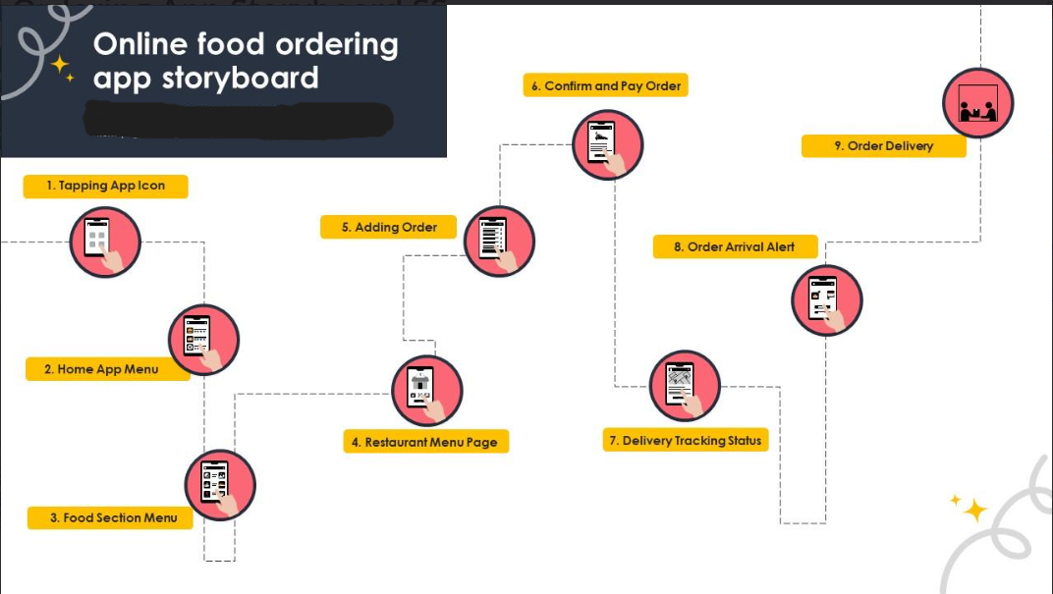

Result:
The experiment demonstrated how storyboards can effectively represent the user flow of a mobile food ordering app. By mapping screens from search to order confirmation, the storyboard provided a clear visualization of navigation, interactions, and decision points. This highlights the importance of low-fidelity design tools like Balsamiq in validating app concepts and ensuring user-centric development.

